

Introduction to Computer Vision

Coursework

Submission 2

Your name Houssem El Fekih
Student number 171031393

Question 4(a)
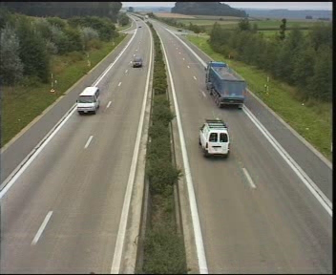
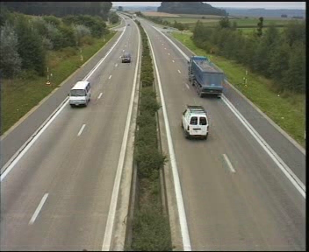

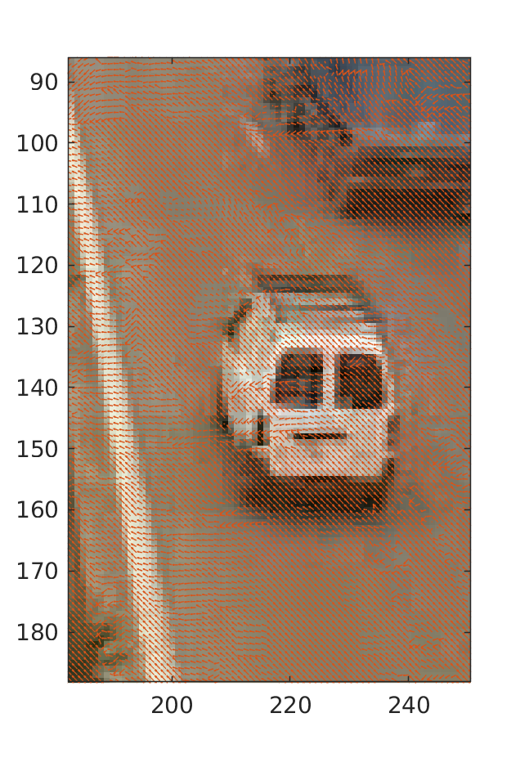
I+1 with motion vectors Zoomed:
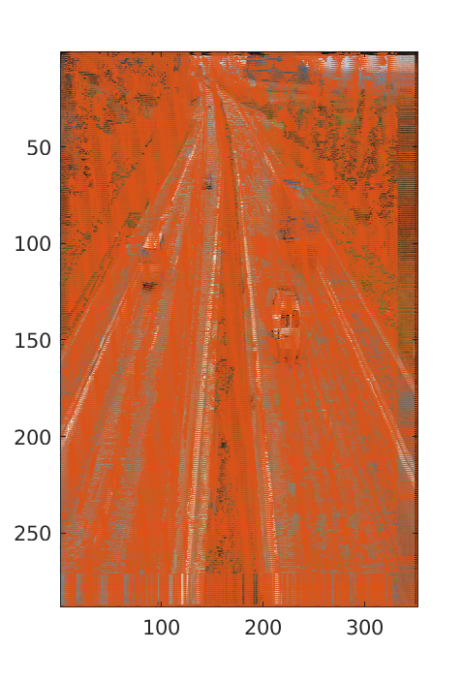

Question 4(b)
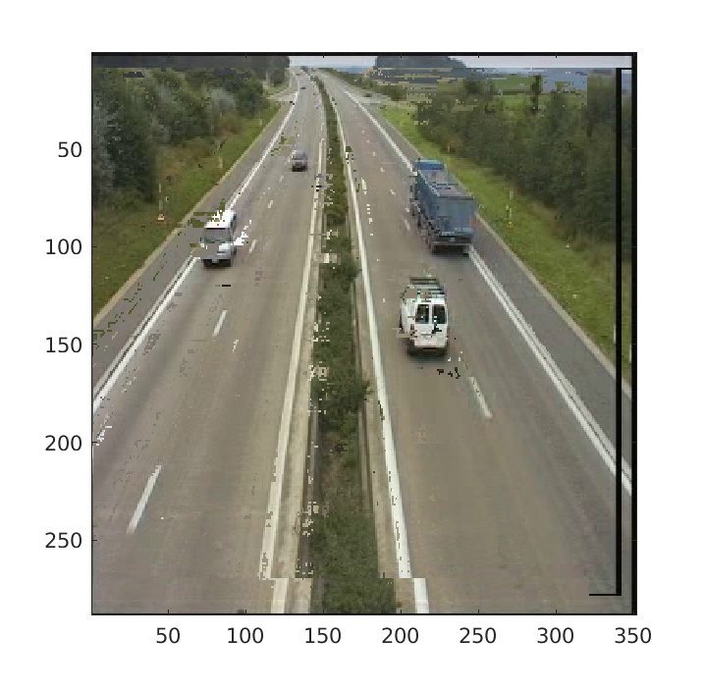

Your comments

At this block size and search window there is a mixed result, on the one hand we correctly identify the trend of the movement of the cars and the structure is still correct but there is a lot of noise and a big distortion around the edges. The algorithm is unable to cope with occlusions, for example the side of the motorway which was covered by the car is not accurately reconstructed.
When reconstructing the image, there would naturally be blank patches since certain areas did not have any pixel mapping to them, to circumvent this problem, the image was initialised as a copy of the original image. This explains the small patches of concrete in the front of the white minibus.

Question 4(c)
Pt+1

Block size = 4x4

Pt+1

Block size = 8x8

Pt+1

Block size = 16x16

Your comments:

This was computed in code but no time to get pictures

Question 4(d)

Pt+1

Window size = 8x8

Pt+1

Window size = 16x16

Pt+1

Window size = 32x32

Your comments:

Also in code timing loop

Question 4(e)
Plot graphs:
Time versus block size

Time versus window size

Your comments:

Question 5(a)
Original frames:
Reference frame

Selected frame 1

Selected frame 2

Frame differencing:

Threshold results:

Your comments:

Question 5(b)
Original frame:
Selected frame 1
Selected frame 2

Frame differencing:

Threshold results:

Your comments for 5a,5b:

Question 5(c)
Generated background

Your comments:

Question 5(d)

Bar plot

Your comments:

an exploratory attempt is included in code Q5.m

Question 6(a)

Three non-consecutive windows
W1
W3
W2

LBP of windows
LBP1
LBP3
LBP2

Histograms of LBPs
H1
H3
H2

Question 6(b)
Two example images:
Face image
Car image

Descriptors:
Face descriptor
Car descriptor

Your comments:

This questions was attempted by reading the question first and not the report. Hence I have not split the windows explicitely but computed the histogram for each window by iterating over the image. The result is the same, however I am unable to easily produce an image of the splits.

Question 6(c)
Block diagram of classification process

for classification we use our global descriptor which is a sum of all the bins for each window
we generate such descriptor on a reference image of a cat and a car.

We then match through histogram similarity on the images.

We will have problems with scale and rotation, we can mitigate scale problem by matching in a scale space.

Your comments:

Question 6(d)
Your comments:

Question 6(e)
Your comments:

Question 6(f)
Your comments

